**Topics: Normal distribution, Functions of Random Variables**

1. The time required for servicing transmissions is normally distributed with *μ* = 45 minutes and *σ* = 8 minutes. The service manager plans to have work begin on the transmission of a customer’s car 10 minutes after the car is dropped off and the customer is told that the car will be ready within 1 hour from drop-off. What is the probability that the service manager cannot meet his commitment?
2. 0.3875
3. 0.2676
4. 0.5
5. 0.6987

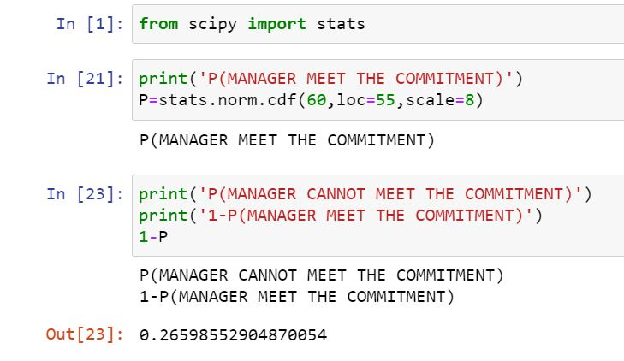

1. The current age (in years) of 400 clerical employees at an insurance claims processing center is normally distributed with mean *μ* = 38 and Standard deviation *σ* =6. For each statement below, please specify True/False. If false, briefly explain why.
2. More employees at the processing center are older than 44 than between 38 and 44.

Ans is **False** ­

Because we get the probability of below 44 age is 0.8413 so the age is below 44 people is more so this statement is **False.**

Calculation is descripted at below screenshot.

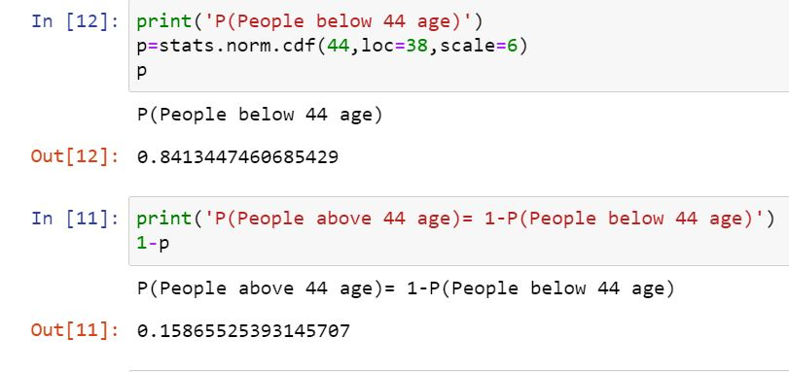

1. A training program for employees under the age of 30 at the center would be expected to attract about 36 employees.

Statement is **True**

Beacaue the under 30 age people probability is 0.091 means 9% . so the 9% of 400 is 36 so statement is **True**

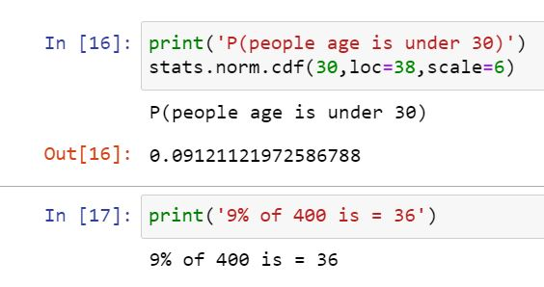

1. If *X1* ~ *N*(μ, σ2) and *X*2 ~ *N*(μ, σ2) are *iid* normal random variables, then what is the difference between 2 *X*1 and *X*1 + *X*2? Discuss both their distributions and parameters.

* In this example X1 and X2 are normal random variable. So both side distribution are same so value of X1 and X2 is same but one is positive and second is nagetive.
* So the X1 + X2 = 0
* 2X1 = some value
* So **2X1 is not equal to X1+X2**

1. Let X ~ N(100, 202). Find two values, *a* and *b*, symmetric about the mean, such that the probability of the random variable taking a value between them is 0.99.
2. 90.5, 105.9
3. 80.2, 119.8
4. 22, 78
5. 48.5, 151.5
6. 90.1, 109.9

Here we have mean= 100 , we have statdard deviation=20 and probability = 0.99 we want to find the value of two points a and b.

1st we find Z transform of both points

We have 0.99 probability so 0.005 both side. So find z transform for 0.005 & 0.995 .

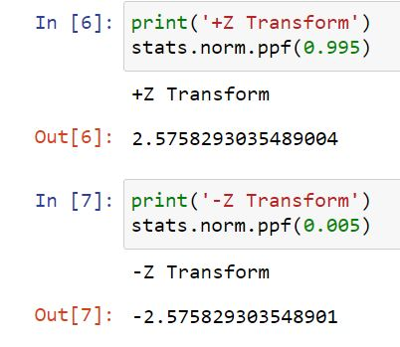

We have equation **Z = x- μ / *σ***

Here we want to fine the value of x

So x = Z(***σ***) + μ x = Z(***σ***) + μ

= 2.57(20) + 100 = -2.57(20) + 100

= 51.4 + 100 = - 51.4 +100

A = 151.4 B = 48.6

This value is find automatically in pyhton by interval function

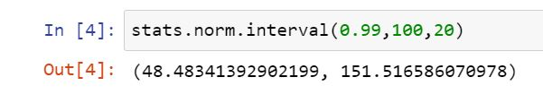

1. Consider a company that has two different divisions. The annual profits from the two divisions are independent and have distributions Profit1 ~ N(5, 32) and Profit2 ~ N(7, 42) respectively. Both the profits are in $ Million. Answer the following questions about the total profit of the company in Rupees. Assume that $1 = Rs. 45
2. Specify a Rupee range (centered on the mean) such that it contains 95% probability for the annual profit of the company.

* Profit 1 = 5*45 Profit 2 = 7*45

= 225 Milion Rs = 315 Million Rs

Total profit = Profit 1 + Profit 2

= 225 + 315

= 540 milion Rs

Same as total Stadard deviation is = 3*45 + 4*45

=315 Milion Rs

In this we want to find interval at 95 % probability

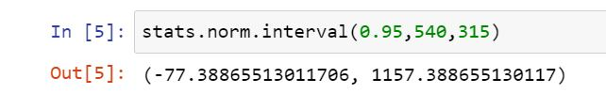

Ans is in million Rs.

1. Specify the 5th percentile of profit (in Rupees) for the company

First we find the z score at 5th percentile means at 0.05

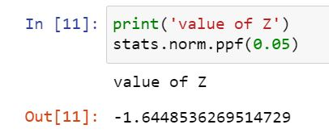

x = Z(***σ***) + μ

= -1.64(315) + 540

**x = 23.4 Milion Rs(5th percentile profit of company)**

1. Which of the two divisions has a larger probability of making a loss in a given year?

For this we find saprate probability at below profit 0

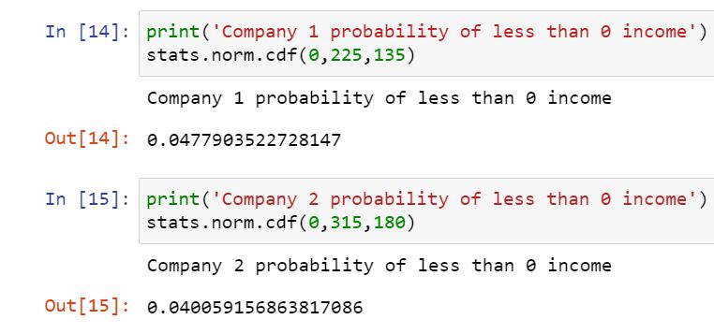

Here we saw company 1’s loss probability is higher than company 2

**So company 1 is make loss more**